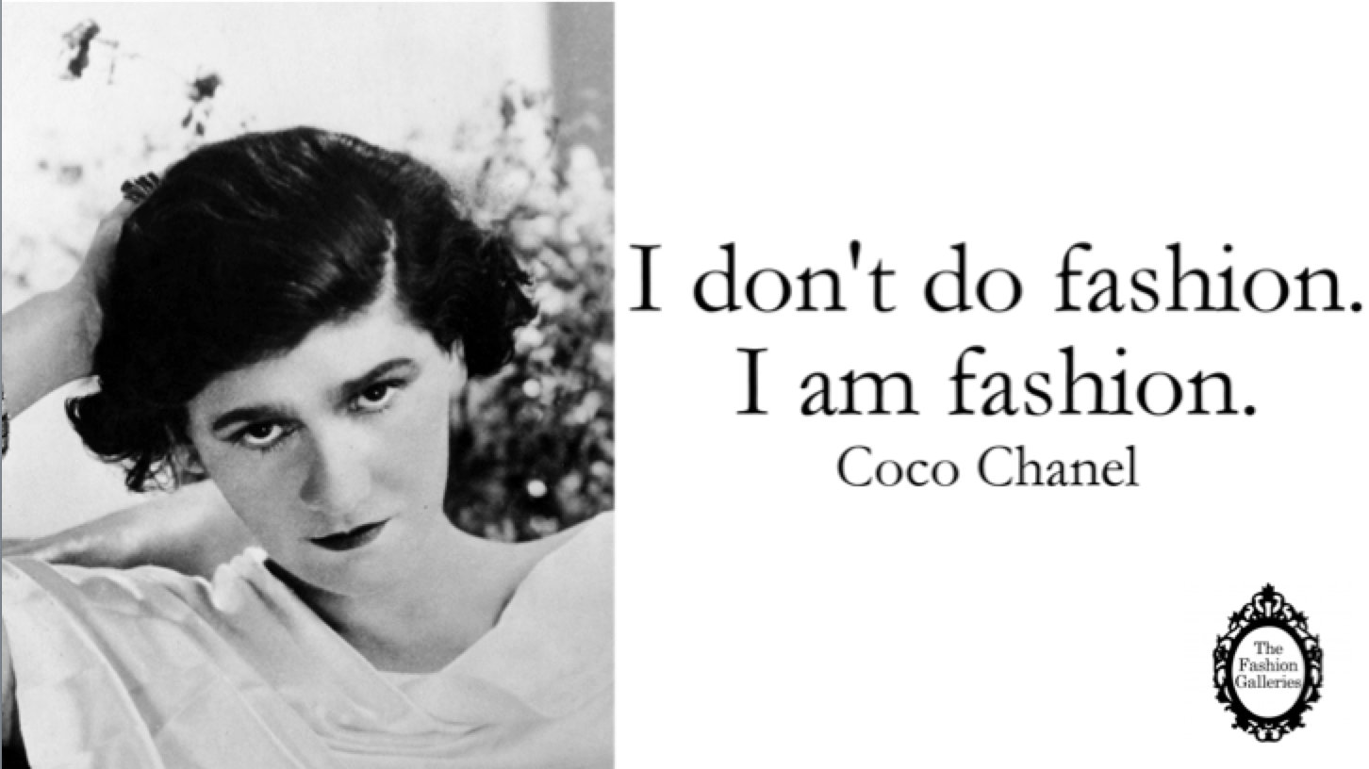

http://golossina.com/historia-de-la-moda-internacional-capitulo-2/

Like the proverbial cat she seemed to have nine lives

Among the leading French designers who revolutionized women’s fashion was Gabrielle ‘Coco’ Chanel (1883–1971). Her view on what is style and how modern women should look, act, and dress changed the whole idea of fashion. Coco Chanel as a designer was included in the list of 100 most influential people of the 20th century.

Gabrielle Chanel lost her mother at 12, so became an orphan in her early childhood, lived in poor house, experienced World War One and Two and, despite of this, survived. As she once said, “The most courageous act is still to think for yourself. Aloud”. Difficult life caused that new gifted designer and a beautiful woman Coco Chanel (‘Coco’ was a nickname obtained in the orphanage where she grew and was taught to sew) appeared on a world fashion stage.

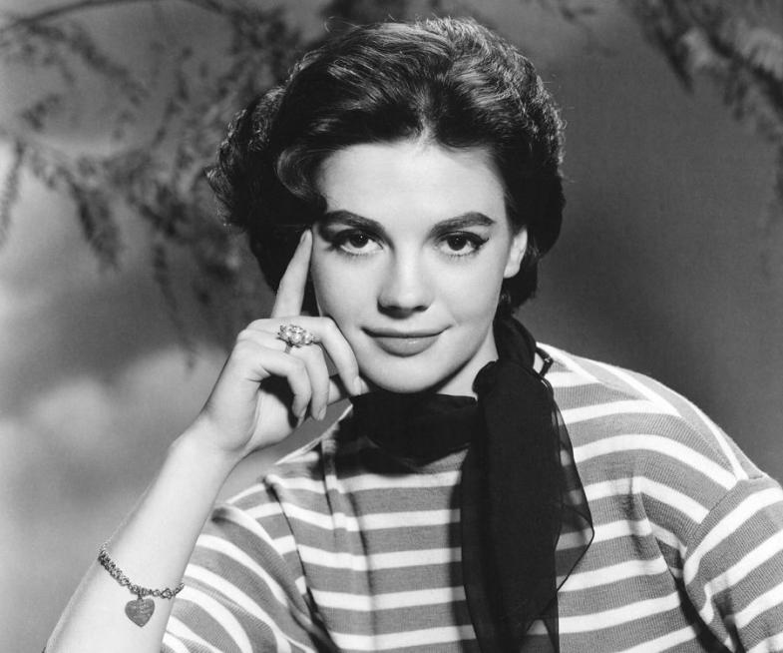

http://fashiontvla.com/celebrities/10-mujeres-que-nos-inspiran_8835

Her fame based on creating of a fundamentally new women cloth fashion and pushing it ahead as opposed to men fashion. Revolution she made consisted in replacing tight corsets, very popular in 19th century, for comfortable costumes. Chanel once said,“luxury must be comfortable, otherwise it is not luxury”.

Chanel’s designer career began when she lived in orphanage where she learnt how to sew getting, though, no salary for her job. First money were obtained from opening a millinery shop in Paris in 1910 sponsored by military officer, then by English industrialist whose mistress she was.

Within a few years, Coco Chanel became well-known in France. She had expanded her business and, besides shops, established a couture house and a textile factory. She popularized simple, casual yet sophisticated suits and cardigan jackets paired with accessories, namely, strands of pearls. This cloth was more feminine than required everywhere and highly impractical corsets and full length skirts.

It was the post war period when woman liberation began. In the 1920s women received the right to vote and work, be socially and politically active. Coco Chanel felt these changes and helped women express themselves in more simple and practical clothing. Once she said: “Fashion has become a joke. The designers have forgotten that there are women inside the dresses”. By 1919, at the age of 32, she enjoyed enormous fame providing services for the clients around the whole world.

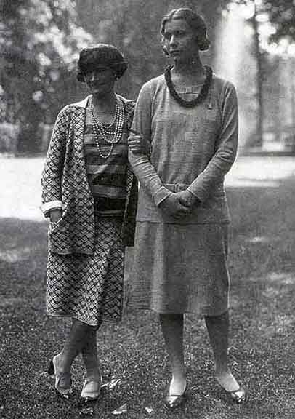

Chanel (on left) with Lady Abdy in 1929

https://www.emaze.com/@AFQOQTRZ/CoCo-chanel%C2%A0CoCo
Another no less known Chanel trademark was a little black dress introduced in 1926. It was Chanel that implemented total black as a color of a new style. Her credo was: “Fashion changes, but style endures”. Love for this timeless design didn’t change from generation to generation and remained very popular until today.
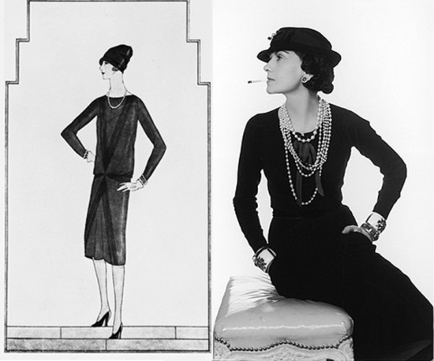
http://www.katherineeleyce.com/style/2014/4/3/the-perfect-lbd-part-1
In the 1922, Coco Chanel also launched a perfume line with a range of perfumes including legendary Chanel No. 5. This scent represents an idea of luxury, elegance and femininity remaining still very popular.
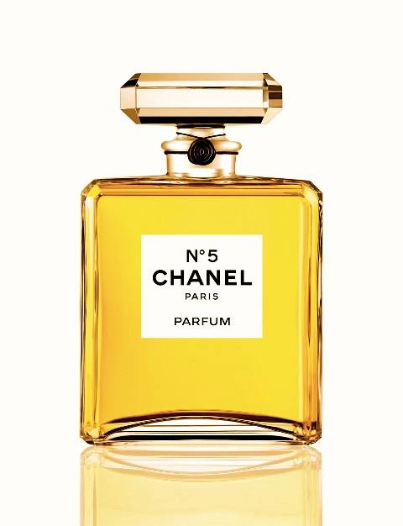

http://www.jenny.gr/123123-ta-5-arwmata-pou-saghneuoun-tous-andres/

Popularity of Chanel house declined significantly, though, with the WW II. For 15 years trend paused its work and returned with a bang only in 1954. Her designs and accessories became extremely popular again. In 1971, great designer Coco Chanel passed away.

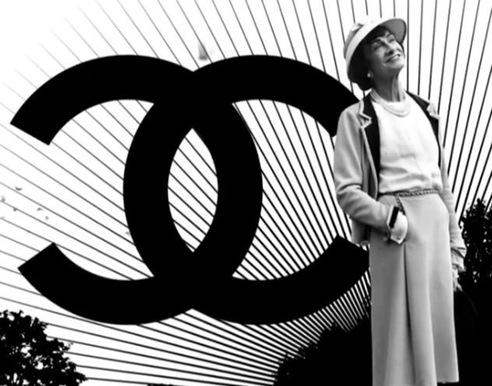

https://twitter.com/enriqueblancoc/media

Changing a fashion on 180 degrees, Coco Chanel was recognized by her colleagues as a genius and a style icon of the 20th century.
With a  black sweater  and  10 rows of pearls Chanel revolutionized fashion.  Dior on  Coco Chanel | 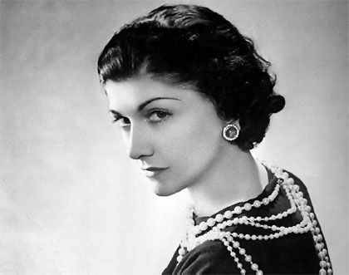
http://www.mispapelicos.com/2016/09/10-things-you-didnt-know-about-pearls.html

